

QlikView Implementation Statement of Work –

[Company]

Abstract

This statement of work summarises the key deliverables of the QlikView Implementation and associated costs.

Data Technology Limited

Croxley Green Business Park

Building 6 Unit 18

Lakeside

Hatters Lane

Watford

WD18 8YR

© 2013 Data Technology Ltd. All rights reserved.

The information contained in this document represents the current view of Data Technology Ltd. on the issues discussed as of the date of publication. Because Data Technology and our partners must respond to changing market conditions, it should not be interpreted to be a commitment on the part of Data Technology or our partners, and Data Technology cannot guarantee the accuracy of any information presented after the date of publication.

This document is for informational purposes only. Data Technology MAKES NO WARRANTIES, EXPRESS OR IMPLIED, IN THIS DOCUMENT.

Complying with all applicable copyright laws is the responsibility of the user. Without limiting the rights under copyright, no part of this document may be reproduced, stored in or manipulated by a retrieval system, or transmitted in any form or by any means (electronic, mechanical, photocopying, recording or otherwise) or for any purpose, without the express written permission of Data Technology.

Data Technology may have patents, patent applications, trademarks, copyrights or other intellectual property rights covering subject matter in this document. Except as expressly provided in any written Licence agreement from Data Technology, the furnishing of this document does not give you any licences to these patents, trademarks, copyrights or other intellectual property.

The names of actual companies and products mentioned herein may be the trademarks of their respective owners.

*Data Technology is registered in England No: 2154023 with registered office at:-*

*Croxley Green Business Park, Building 6 Unit 18, Lakeside, Hatters Lane, Watford, WD18 8YR*

**Commercial Statement**

**Accuracy**

Data Technology endeavours to ensure that the information contained in this document is correct, and whilst every effort is made to ensure the accuracy of such information it accepts no liability for any error or omission in the same.

**Non-Disclosure**

The information contained in this document is confidential and is submitted by Data Technology on the understanding that it is used for the purposes of evaluation only. In particular the contents of this proposal may not be disclosed in whole or in part to any other third party without the prior express written consent of Data Technology.

**Copyright**

The information contained in this document is the copyright of Data Technology Limited. The information may not be distributed to any third parties except with the express written permission of Data Technology and then only if this note is reproduced in its entirety.

**Validity**

The information contained within this document shall remain valid for a period of 30 days from date of submission. Any requested extension to this period shall not be valid unless confirmed by Data Technology in writing and may result in a variation of the terms contained herein.

**Disclaimer**

Data Technology provides the information contained herein for information and evaluation purposes only and does not warrant the use of it for any purpose or to derive any particular business benefit.

Document Control

Distribution

|  |  |
| --- | --- |
| Name | Organisation |
| xxxx | [company] |
| xxxxxxx | Data Technology |
| xxxxxxx | Data Technology |
| xxxxxxxx | Data Technology |

Version History

|  |  |  |  |
| --- | --- | --- | --- |
| Version  Number | Revision  Date | Summary of Changes  **(List the reason for each version of the document)** | Author |
| V1.0 | 25/02/2015 | Initial Document | GT |
| V1.1 | 27/02/15 | Added detailed schedule | GT |
|  |  |  |  |
|  |  |  |  |
|  |  |  |  |

Contents

1 Introduction 6

1.1 Background 6

1.2 Overall Project Objective 6

1.3 Document Objective 6

1.4 Contact 7

2 QlikView - Implementation Scope 8

2.1 Deliverables 8

2.2 High Level Project Schedule & Milestones 11

2.3 Detailed Project Schedule & Milestones 12

3 Financial & Technical Considerations 13

3.1 Introduction and Assumptions 13

3.2 Total Charge 14

4 Proposed Data Architecture & Source Data 15

4.1 E-Commerce Dashboard 16

4.2 Daily Services Dashboard 17

4.3 E-Trading Dashboard 18

5 Reports Mockups 19

5.1 E-commerce Dashboard 19

5.2 Daily Services Dashboard 20

5.3 E-Trading Dashboard 21

6 Metrics Explanations 22

6.1 E-commerce Dashboard 22

6.2 Daily Services Dashboard 23

6.3 E-Trading Dashboard 24

# Introduction

## Background

[company] has the requirement of extending the suite of daily reports capturing the performance of their ecommerce/etrading activity in terms of revenue as well as the site performance in terms of OTIF and call centre data. Data Technology will be working alongside with them to achieve their requirements.

## Overall Project Objective

The stated project objectives are to:

* Provide an analytical business discovery platform which allows self-service analytics and to reproduce as fully as possible the mock-up reports as provided by way of example.

## Document Objective

The objective of this document is:

* Design and Implementation Summary with a statement of associated costs.

## Contact

Any questions relating to this document should be addressed to:

|  |  |
| --- | --- |
| **Account Management** | **Project Delivery** |
| C:\Users\owner\Desktop\DT logo.jpg  **Seatal Patel**  Executive Director  T: +44 (0) 845 658 8480  M +44 (0) 788 793 2289  E: sxp@datatechnology.co.uk  Data Technology Limited  Unit 18, Building 6  Croxley Green Business Park  Watford  WD18 8YH | C:\Users\owner\Desktop\DT logo.jpg  **George Tsartsalis**  Qlikview Technical Consultant  T: +44 (0) 845 658 8480  M+44 (0) 758 476 2647  E: gt@datatechnology.co.uk  Data Technology Limited  Unit 18, Building 6  Croxley Green Business Park  Watford  WD18 8YH |
|  | C:\Users\owner\Desktop\DT logo.jpg  **Sabah Dada**  Qlikview Developer  T: +44 (0) 845 658 8480  M+44 (0) 777 235 7539  E ssd@datatechnology.co.uk  Data Technology Limited  Unit 18, Building 6  Croxley Green Business Park  Watford  WD18 8YH |

# QlikView - Implementation Scope

## Deliverables

The following tables detail the deliverables Data Technology will produce during each phase of the project along with the resource requirements and implementation approach.

| **ID** | **Title** | **Approach and Resource Requirements** |
| --- | --- | --- |
| D1 | **QlikView Application Design & Data Architecture**  Discuss, Agree, Test & Document the QlikView Application Design / Data Architecture.  This deliverable will include the following:   1. Confirm each one of the data sources which are required. 2. Confirm how the QlikView Application will access the data sources. 3. Confirm the format / layout for each one of the data sources. 4. Achieve connectivity to each data source and confirm record count. 5. Implement the Qlikview Extract layer (QVW) based on the agreed rules for each data source. 6. Implement the Qlikview Data Model layer (QVW) based on the relationships between the data. | The approach taken to deliver this is as follows:   * Technical Session(s) between Data Technology and The Consortium. * The Consortium will make available all resources required to attend this workshop i.e. individual who understand the data sources, data connections, data and Reports required. * Data Technology will provide a QlikView Architect /Developer. * The Consortium will make available all systems and data sources to enable Data Technology to prove connection to each data source and confirm record counts. * Data Technology will document the outcome of the session and the final QlikView Design and proceed to the implementation of the Extract and Data Model layers. |
| D2 | **QlikView Dashboards / Reports**  Development of the following Qlikview Dashboards / Reports  **E-Commerce Dashboard**  A single page dashboard capturing the e-commerce activities in terms of revenue & a set of relevant Google Analytics metrics.  **Daily Services Dashboard**  A single page dashboard capturing site performance in terms of OTIF and Call centre data.  **E-Trading Dashboard**  A single page dashboard capturing the e-trading activities in terms of revenue and | The approach taken to deliver these is as follows:   * The Consortium will provide all data required to populate QlikView; this should include table names and primary key link information. * User requirements will be reviewed in detail and consolidated into a QlikView application. * The Consortium will provide all algorithms required for the report. * Data Technology will build the 1st Iteration of QlikView application. * Deploy in test environment      * The Consortium 1st Iteration review of QlikView application. * User requirements will be reviewed and 2nd Iteration will be developed. * The Consortium 2nd Iteration review of QlikView application. * User requirements will be reviewed and 3rd and Final Iteration will be developed. |
|  |  |  |
| D3 | Solution documentation sufficient to enable on-going self-service or off-line application management.  The documentation shall record:   * A detailed description of each data source utilized their source paths and format. * The Qlikview App architecture as it was implemented along with the dependencies/ execution chain between the different layers (QVWs) * A Briefing of each layer (QVW) implemented covering it purpose and place in the overall architecture. * A Briefing of every tab/report in the report layer, covering the purpose of each along with the KPIs presented. * The deployment details for the app on the server. | The approach taken to deliver this is as follows:   * The QlikView documents as developed and reviewed in detail as a result of the project phases be recorded by Data Technology in a suitable medium.      * The Consortium Pharmaceutical will verify the accuracy of this documentation. * The documents will be signed off by The Consortium and become their property. |

## High Level Project Schedule & Milestones

| **ID** | **Title** | **Days** | **Completion** |
| --- | --- | --- | --- |
| S1 | Data Technology to develop and submit Statement of Work for Project following our technical sessions with the consortium. | 3 | Already Complete |
| S2 | The Consortium sign-off Statement of Work and Data Technology Work Order. | 0 |  |
| S3 | D1 - QlikView Data Modelling | 2 |  |
| S4 | D2 - QlikView Report Development, allowing up to 3 iterations | 13 |  |
| S6 | D3 – QlikView Application Documentation | 2 |  |
| S7 | Onsite Report Delivery and customization as required by the customer. | 2 |  |

## Detailed Project Schedule & Milestones

| **Task** | **Start Date** | **Date of Delivery** | **Completion** |
| --- | --- | --- | --- |
| On SiteTechnical Sessions – SOW | 23/02/15 | 25/02/15 | Already Complete |
| Base Data Modelling and handover to Developer. | 26/02/15 | 27/02/15 |  |
| Daily Services Dashboard Development | 02/03/15 | 05/03/15 | 1st Iteration |
| E-Trading Dashboard Development | 05/03/15 | 10/03/15 | 1st Iteration |
| E-Commerce Dashboard Development | 10/03/15 | 17/03/15 | 1st Iteration |
| All 3 Dashboards | Ongoing | 20/03/15 | 2nd/3rd Iteration as required |
| On Site Report Delivery and fine-tuning | 23/03/15 | 24/03/15 | 2 Days on site as required |
| Report Documentation | TBC | TBC |  |

# Financial & Technical Considerations

## Introduction and Assumptions

The following sections contain the charges for the deliverables as set out previously in this document. The following assumptions apply:

* All charges exclude VAT;
* Charges shown are fixed and will be invoiced as consumed by the consultants up to the total price amount, only actual days will be invoiced.
* Mileage will be charged at 50 pence per mile and other expenses at cost for any work carried out on-site.
* Complete functional requirements are agreed by iteration with the Consortium team to the level that enables a reasonable attempt to deliver a QlikView view, including the identification of required data sources and access to them for extract purposes.
* Additional work will be subject to Project Change control and may incur additional charges.
* Remote VPN access will be required (under The Consortium security methodology) to all data sources.
* Full read access to all required data sources will be provided either in the form of folder access or DB user account access depending on the nature of the data source. (export/SQL DB connection)
* Full read/write access to the QlikView Server deployment location as well as admin rights to the QlikView Server Management Console will be provided.

## Total Charge

Any changes to the content of the deliverables or delay caused due to circumstances not under Data Technology control will be managed with the customer Project Manager with Change Management governance applied as appropriate.

Charge breakdown as per the rate card above:

|  |  |  |  |
| --- | --- | --- | --- |
| **Task** | **Days** | **Rate** | **Cost** |
| QlikView OnSite Consultancy | 3 (already covered)  + 2 | £650 | £ 3250 |
| QlikView OffSite Development | 15 | £500 | £ 7500 |
| Documentation | 2 | £500 | £ 1000 |
|  |  | **Total** | £11,750 |

# Proposed Data Architecture & Source Data

This section records the proposed data architecture, capturing all the different data sources required as well as the way they flow into the different dashboards.

The list of the date sources for the purpose of this project are

1. **System21**

This is the Consortium’s internal CRM solution which holds the majority of the core business data. The Consortium has already a number of extracts/models developed and deployed which should give us access to most of the data required for the purpose of developing these dashboards. If any extra tables are required from the source system we will develop further extracts from System21 abiding to the current extract approach in place.

1. **Google Analytics**

The business uses this Google service for the purpose of monitoring the activity against its series of commercial websites. The third party product qvsource and the relevant GA connector will be used to extract the relevant data from this service. A differential load will be implemented to avoid any unnecessary calls to the API on a daily level.

1. **MCC**

This is the Consortium’s call centre management system. There is already an operating extract from this system which we will be using after applying all the appropriate filters.

1. **Spreadsheets**

A number of data sources might require to be maintained in a spreadsheet such as the targets for the SIP Dashboard and the salesperson activity for the E-Trading dashboard.

As it is to be expected, the result of the extracts will be a set of QVDs which will be used to build up the relevant data models. The chart below depicts the QVDs (not accurate names) in blue boxes and the Qlikview documents implementing the logic in green also referred to as QVWs. As shown, the entirety of data sources will be fed into the **Model/Report** layers of each corresponding report both of which will be implemented within a single QVW. When possible a binary load approach will be followed to improve loading performance.

## E-Commerce Dashboard

Based on

## Daily Services Dashboard

## E-Trading Dashboard

# Reports Mockups

The following example reports provided will act as a reference point for the development of the Qlikview App. Visualisation and general objects arrangement will differ and where applicable QlikView features that visualise the results in a more efficient way will be employed.

## E-commerce Dashboard

This dashboard page will present all the relevant metrics/KPIs in a single tab/view organized in a grid fashion; grouped by category. The main purpose of the dashboard will be to be exported as a single page (PDF/Image) which the e-commerce team may then annotate and distribute to the user community.

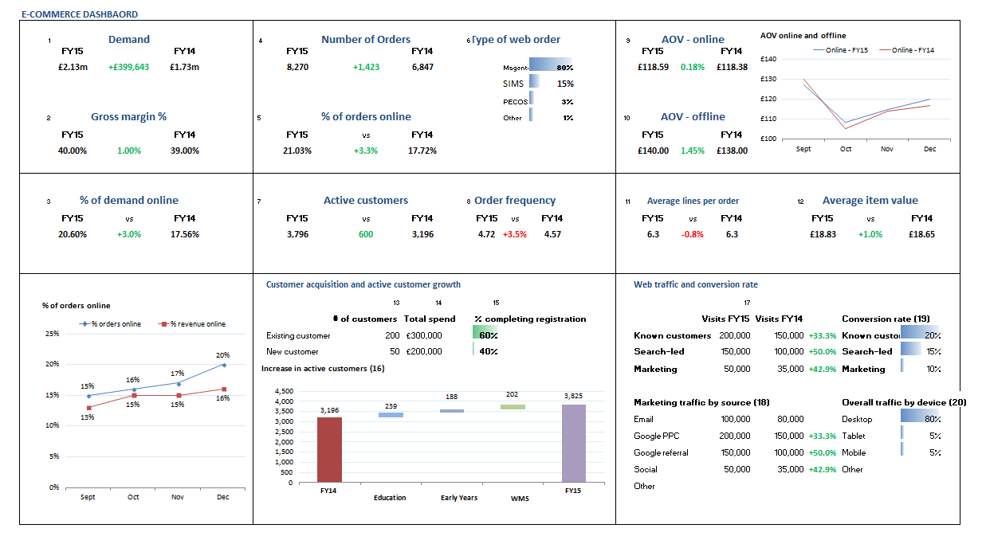

## Daily Services Dashboard

This dashboard page will present all the relevant metrics on a single page. The suggested design approach is to present the overall KPI numbers at the top, combined with a line chart for each of the required trends required. A table at the bottom of the page should present the breakdown of this data into a set of customer segments as well as the total values. Note that the customer segments are not discrete and they will need to be defined independently. The values presented will be against the last complete date.

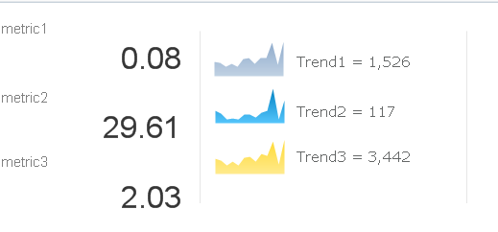

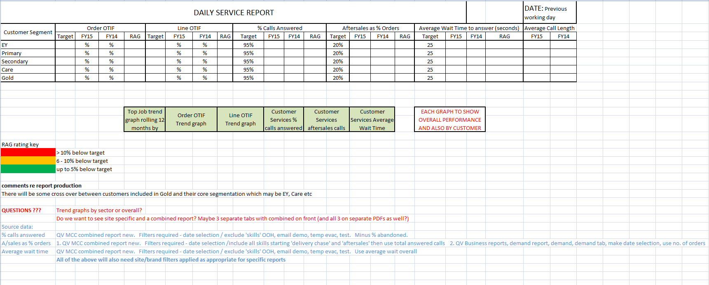

## E-Trading Dashboard

This dashboard page will present all the relevant metrics on a single page. The suggested design approach is to present the major KPI number at the top in conjunction with line charts showing the trends for these over time. A number of tables will then be available at the bottom, showing the detailed figures by week. The values presented will be against the last complete week.

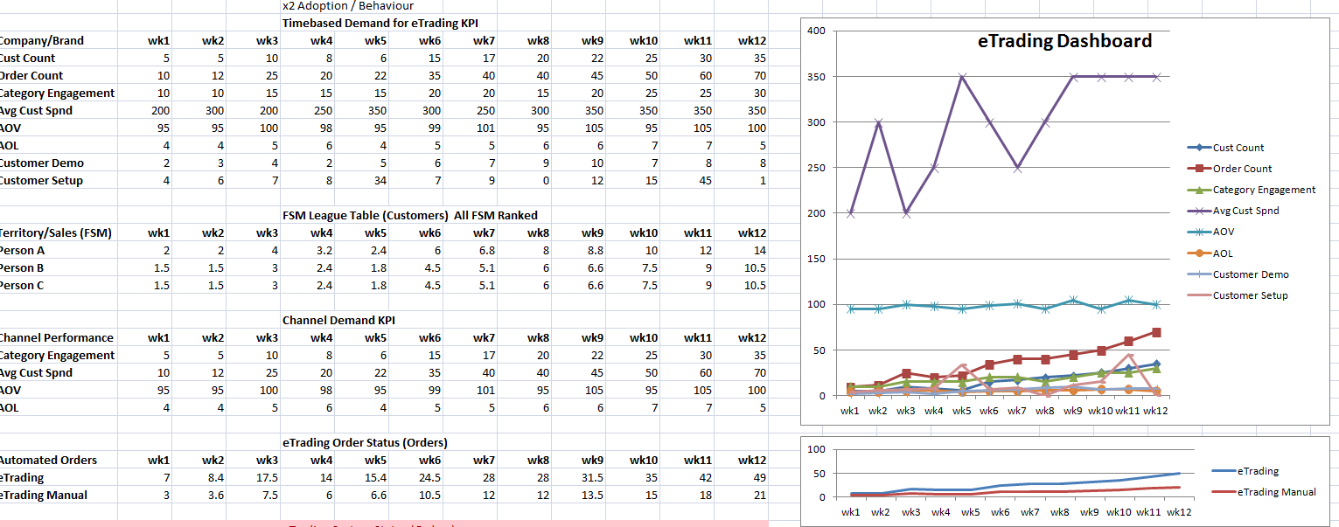

# Metrics Explanations

## E-commerce Dashboard

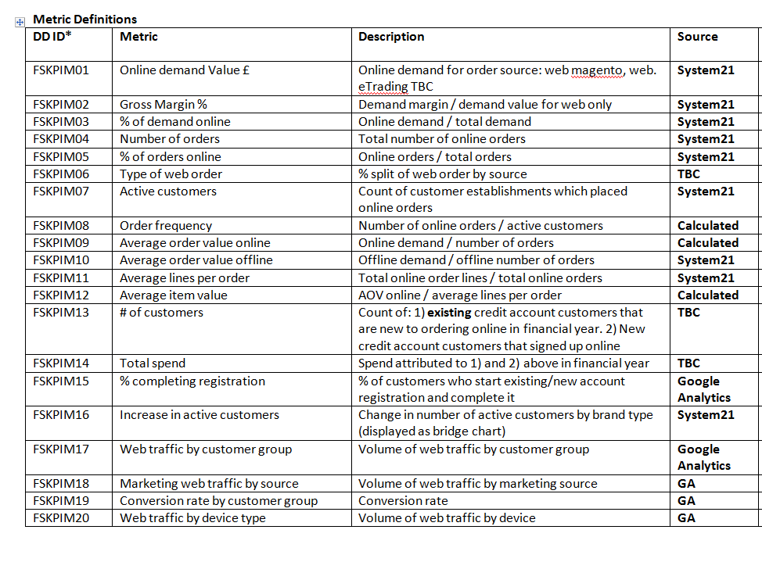

Metrics 06,13,14 are currently out of scope as the business will need to confirm the way these should be generated. All the System21 data will be loaded directly from the Demand Model whilst the GA data will be generated from a separate extract powered by the QV Source GA connector.

## Daily Services Dashboard

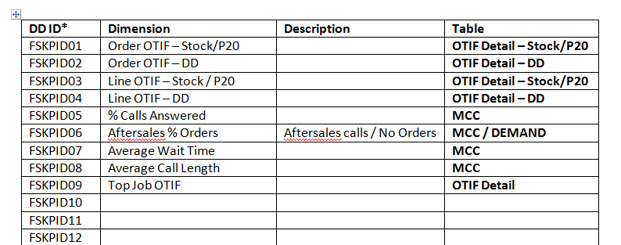

## E-Trading Dashboard

